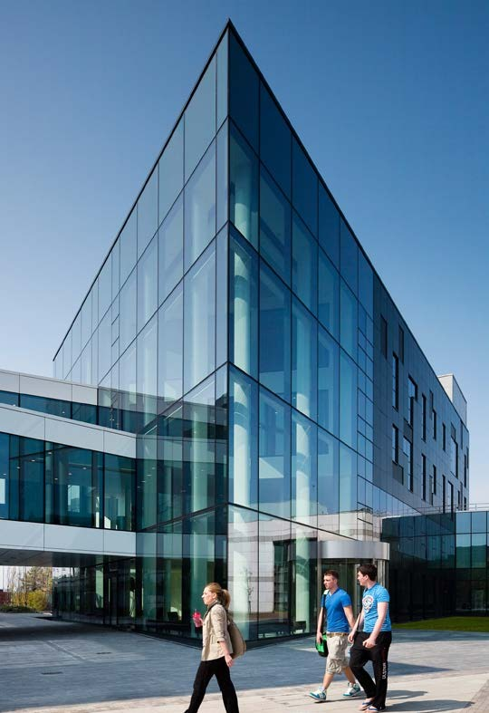

CAREER DEVELOPMENT RSP MEETING

Additional document for final year

School of Biology and Environmental Science

CAREER DEVELOPMENT RSP MEETING
Additional document for Year 4

GUIDELINES ON THE CAREER DEVLEOPMENT RSP
SBES is committed to improving the career prospects of our postgraduate research students. This additional document should be completed for inclusion at an RSP meeting in your final year to inform a discussion with your panel on your future career plans and what steps you have taken or could take to facilitate this.

Student name:

Student Number:

Supervisor:

Date

YOUR CAREER DEVELOPMENT PLAN

Have you discussed your career plans with your supervisor?
Yes ☐
No ☐

Are you familiar with the Careers advice and help available within UCD?
Yes ☐
No ☐

Are you aware of current funding opportunities should you wish to continue a career in academia?
Yes ☐
No ☐

Please give a brief summary of your career plans

What approach are you taking for your future career goals?

Are you using you Career connect account? If so, please supply a summary of the tools you have used in this platform

Comments from the RSP

Signature: Date

_______________________________ _______

